More collections

* Hashes like arrays but
  + Keys can be anything;
    - Strings and symbols common
  + No natural ordering like numeric indices
  + Different syntax to make them

Like a dynamic record with for field names

* + Often pass a has rather than many argument
* Ranges like arrays of contiguous numbers but:
  + More efficiently represented, so large ranges fine

Good style to:

* Use ranges when you can
* Use hashes when non-numeric keys better represent data

Example of hashes

Creation of empty/new hash



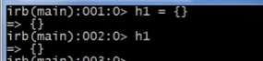

Adding records in the hash

* *Hash*[*key*] = *value*





Accessing indices that does not exists

* Return nil



Return the current keys



Return the current values



Create hash directly





Checking the size



.each

* Block needs to have 2 args: key and value

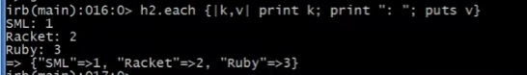

Example of ranges

* lowerbound..upperbound



* not an array!

.inject (reduce)



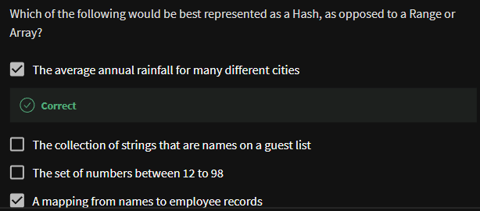



Similar methods

* Arrays, hashes, and ranges all have some methods other don’t
  + e.g., keys and values
* But also have many of the same methods, particularly iterators
  + great for duck typing
  + both range and array have the same methods so we can use the same method foo!
  + example

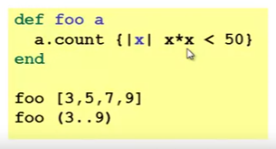

Once again separating “how to iterate” from “what to do”